21 April 2026
NAME: UMMA AMINU | Age: AD | Sex: F | Ref No:
Clinical Details: OBS
REAL TIME PELVIC ULTRASONOGRAPHY EXAM: REVEALED:

URINARY BLADDER: Distended with urine with normal mucosal thickness. No gross masses or stone seen.

UTERUS: The uterus is gravid and shows single live embryo in the uterine cavity with cardiac activity. The cervical Os is closed. Right and Left adnexa are free.

CUL-DE-SAC: No sonographic abnormalities detected in anterior and posterior cul-de-sac.

Biometry:
- CRL = 38mm
- EGA = 10 weeks 05 day(s)
- EDD = 17/11/2026 (±2weeks)

CONCLUSION: Single live embryo at 10 weeks 05 day(s) GA.
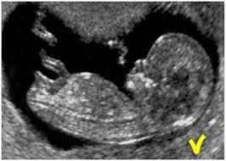

Ultrasound Specialist.

